**DIWALI SALE ANALYSIS**

**By USING PYTHON**

**OBJECTIVE:**

* Improve customer experience by analyzing sales data.
* For increasing revenue

**STEPS USE FOR ANALYZING DATA:**

**STEP 1.** Import libraries such as numpy, pandas, matplotlib.pyplot and seaborn.

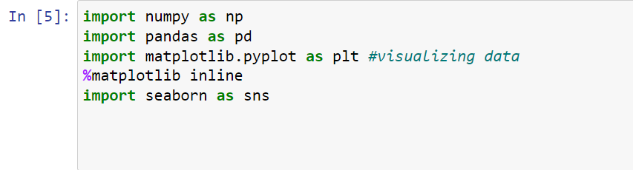

**STEP 2.** Import Diwali Sales Analysis csv file on python.



**We use Latin1 to avoid encoding error.**

**STEP 3.** Data Cleaning.

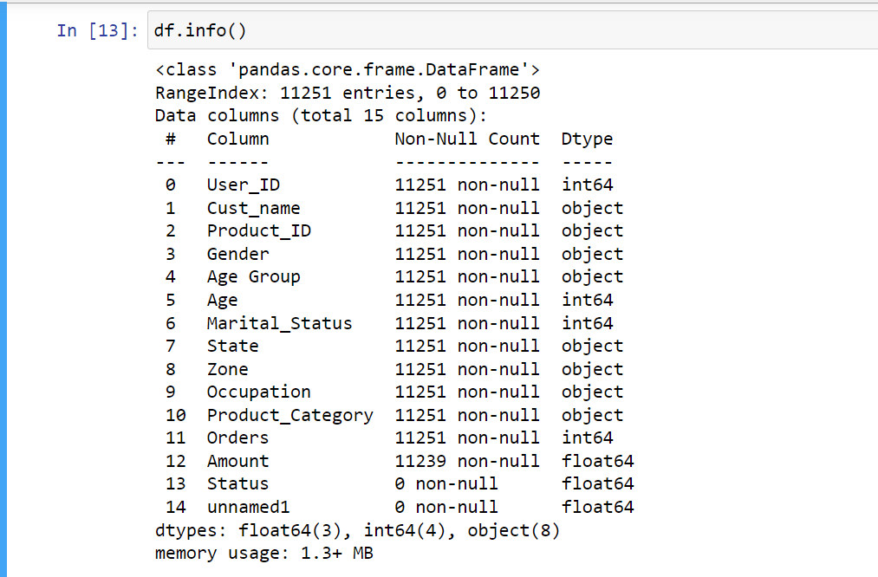

**Status and unamed1 are 2 columns which are null.**









**We can see after change datatype to ‘int’ by using astype the value of amount now becomes integer.**

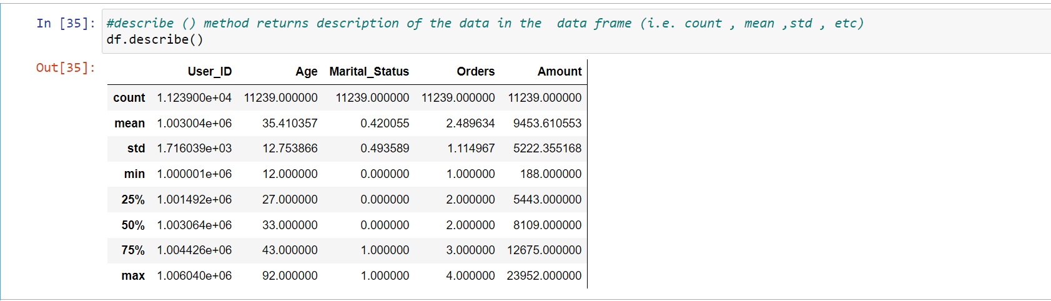

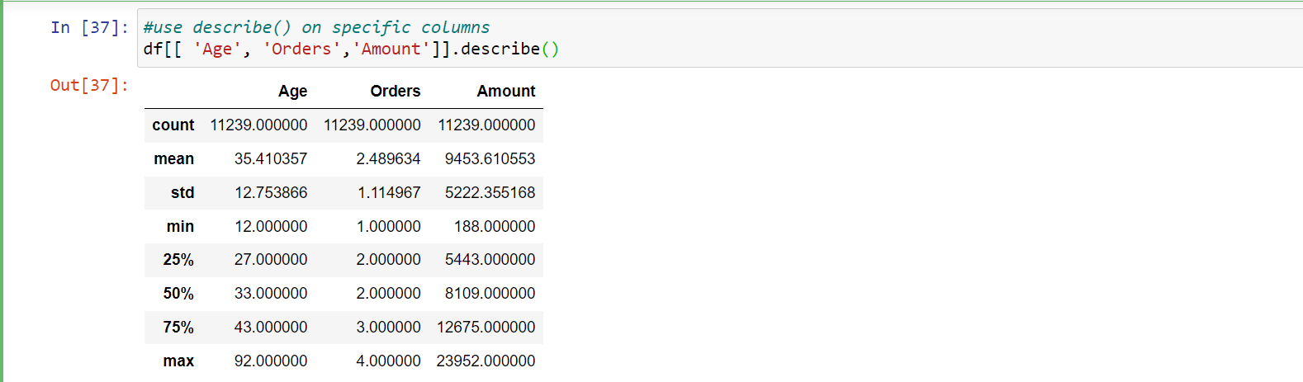

**After doing all these steps Data Cleaning is completed.**

**STEP 4.** Exploratory Data Analytics

**1.GENDER**



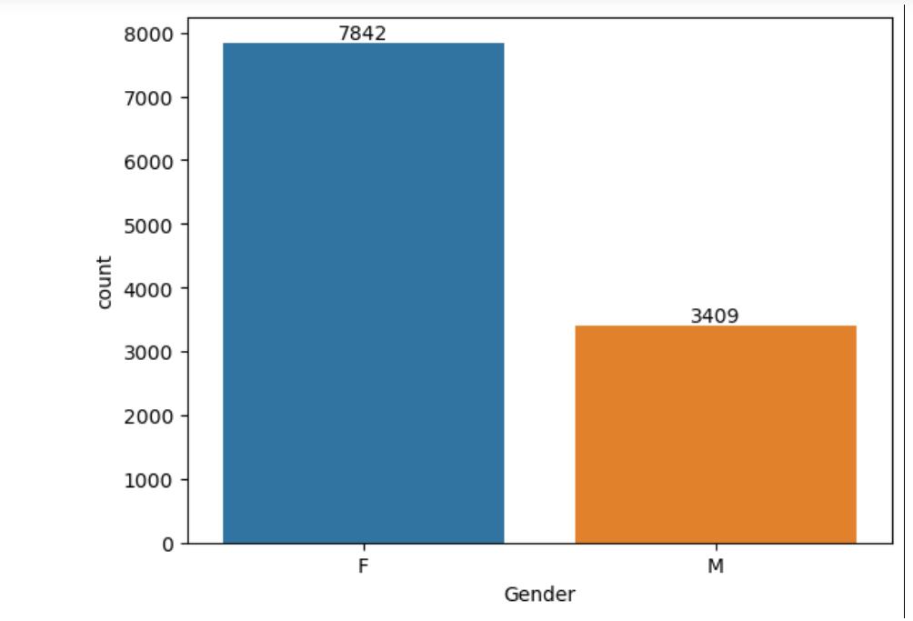

**From above graphs we can see that most of the buyers are females and even the purchasing power of females are greater than men**

**2.AGE**



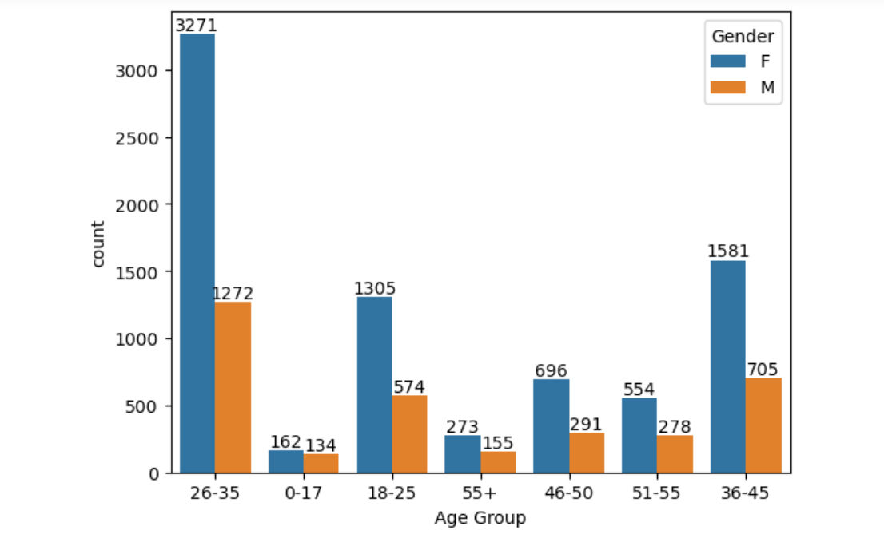



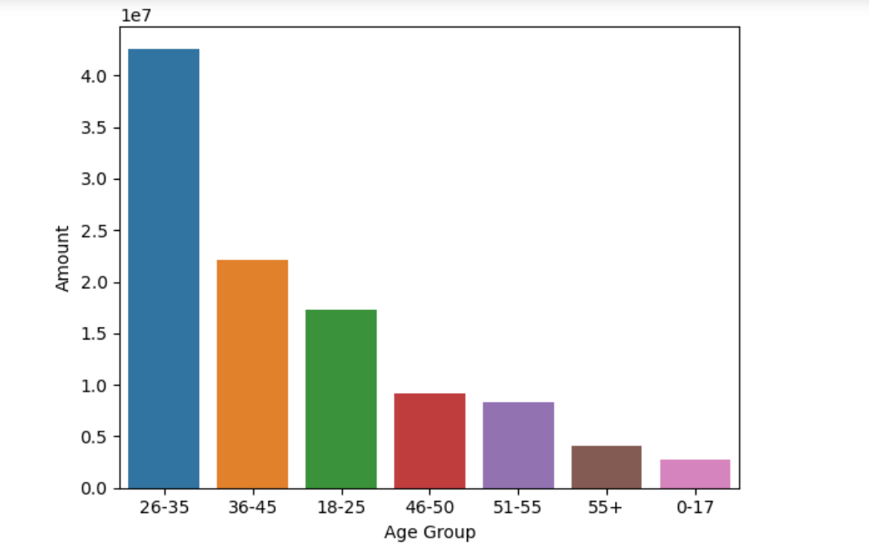

**From above graphs we can see that most of the buyers are of age group between 26-35 years female**

**3.STATE**

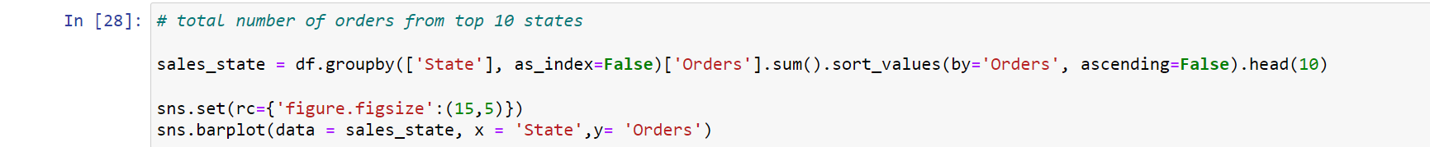

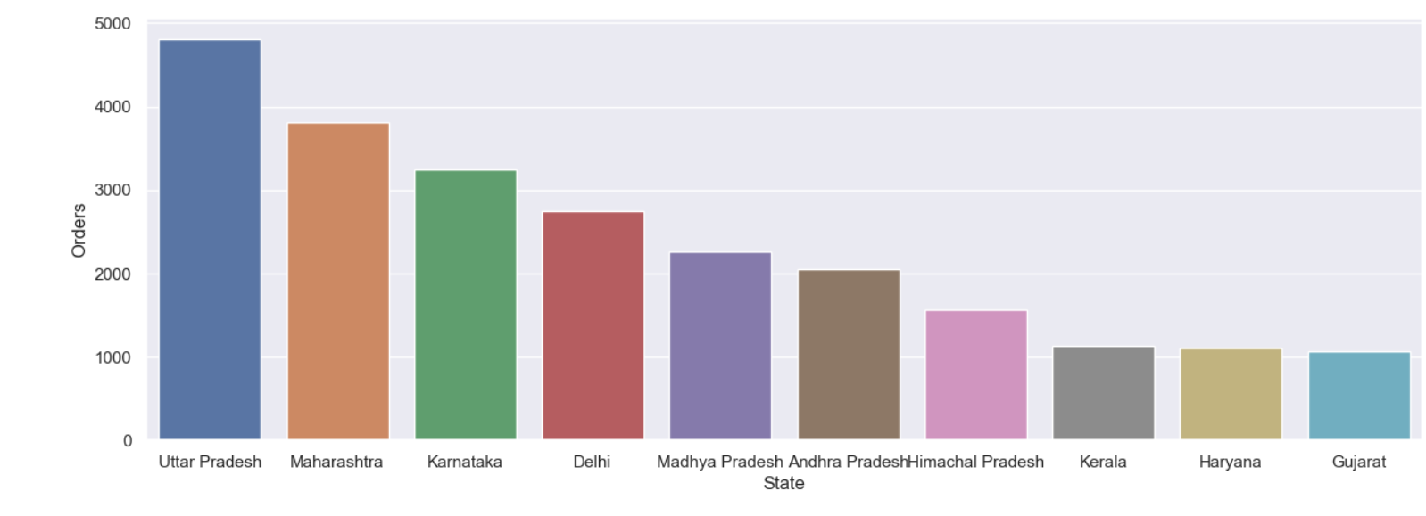

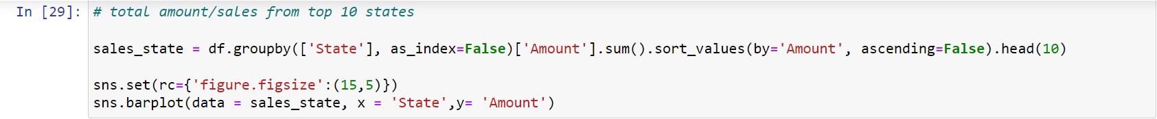

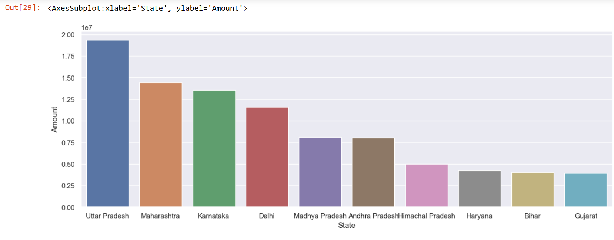

**From above graphs we can see that most of the orders & total sales/amount are from Uttar Pradesh, Maharashtra and Karnataka respectively.**

**4.MARITAL STATUS**

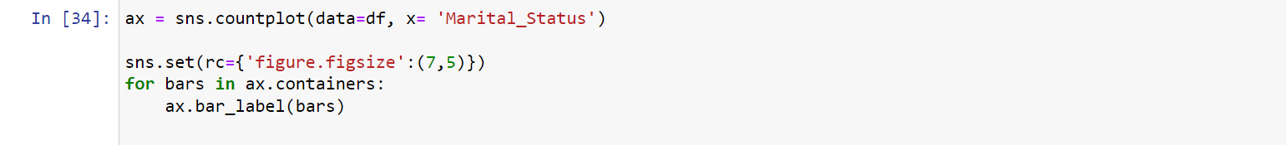

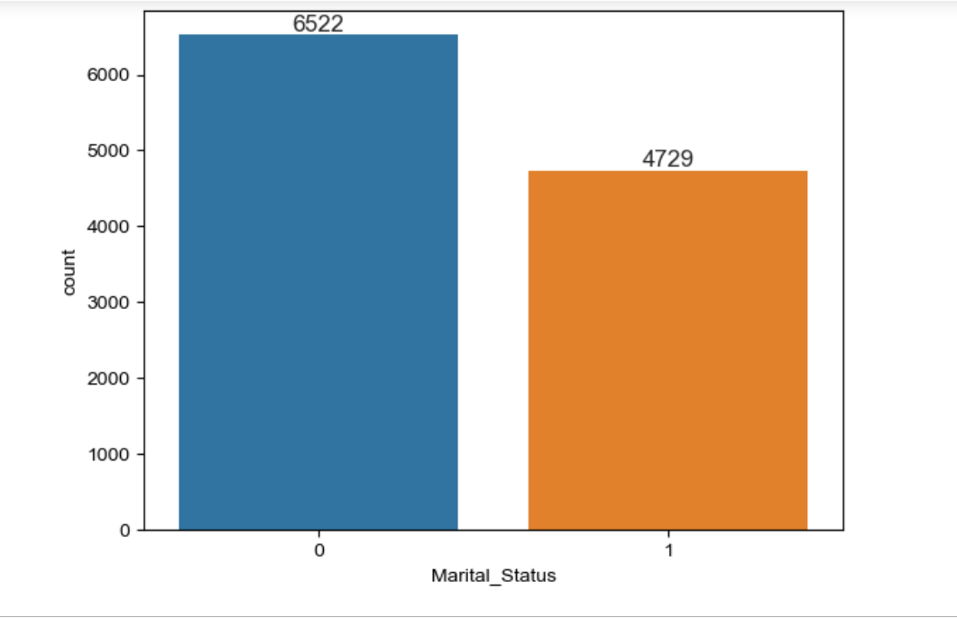



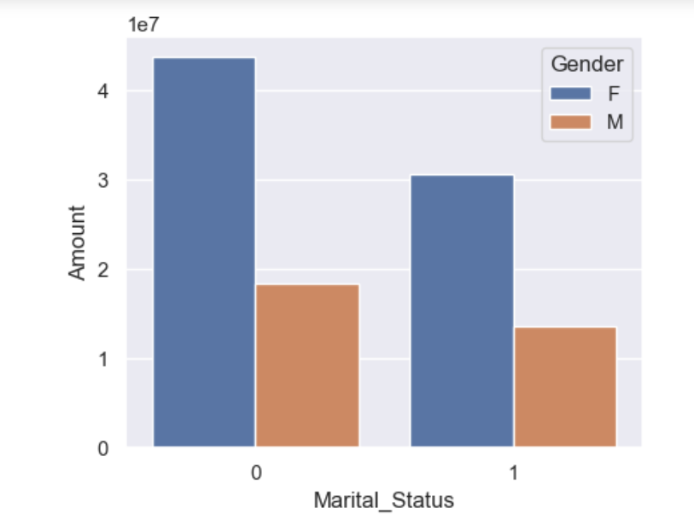**From above graphs we can see that most of the buyers are married (women) and they have high purchasing power.**

**5.OCCUPATION**

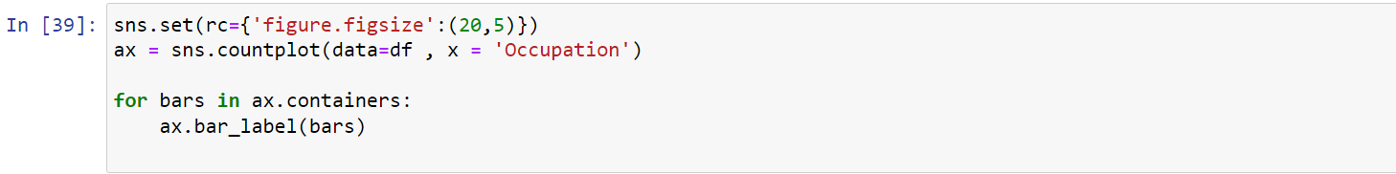

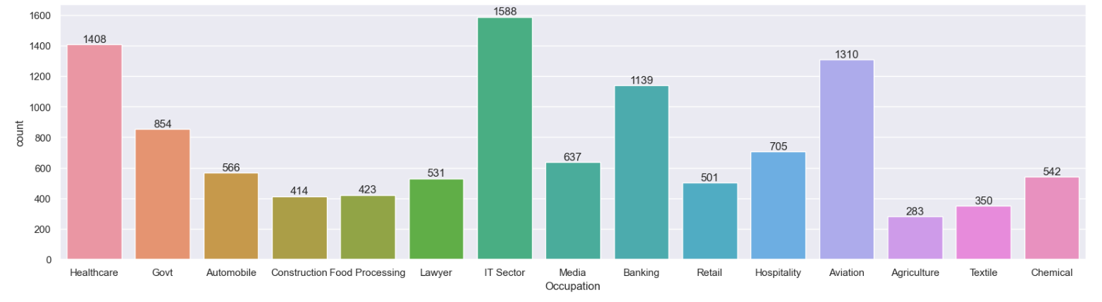



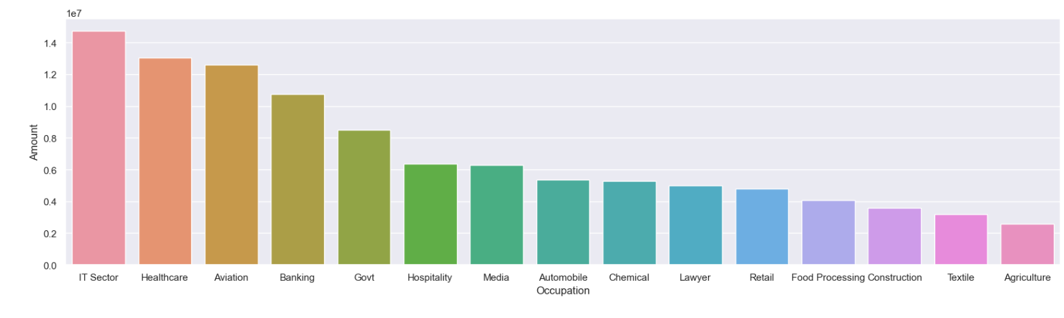

**From above graphs we can see that most of the buyers are working in IT, Healthcare and Aviation sector.**

**6.PRODUCT CATEGORY**

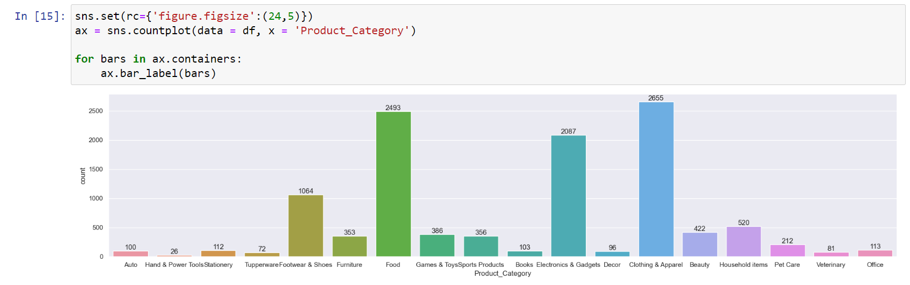

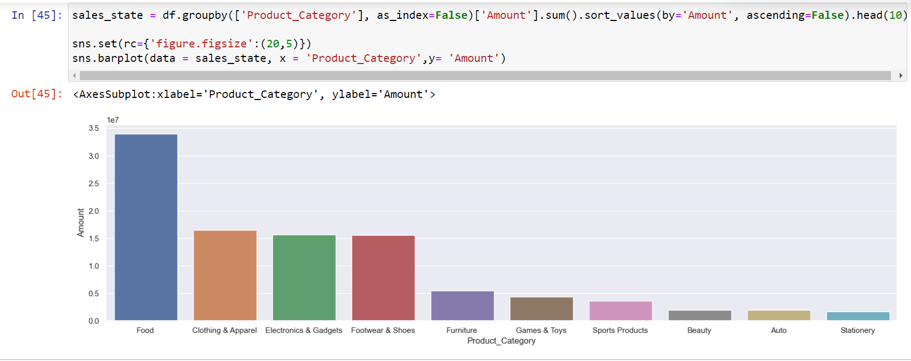

**From above graphs we can see that most of the sold products are from Food, Clothing and Electronics category**



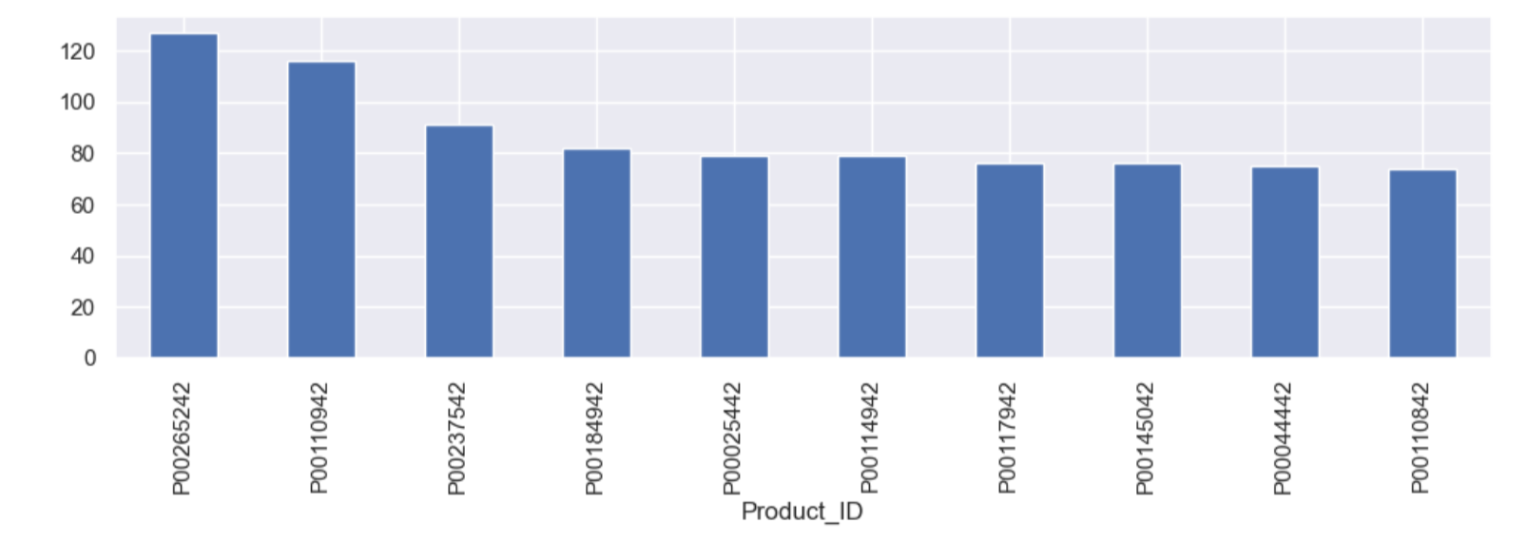

**CONCLUSION:**

Married women age group 26-35 years from UP, Maharashtra and Karnataka working in IT, Healthcare and Aviation are more likely to buy products from Food, Clothing and Electronics category

**Thank You!**